SCSR2043 OPERATING SYSTEMS
[20 Marks]

Name | : | MOHAMMED MOHSEN  MOHAMMED ALSAKKAF |  |  |  | Marks
Student ID | : | A23CS4026
Section | : | 03

Instruction: Please answer all of the following questions.

- Type the following commands using a text editor and save it as a yourname.sh (Example: ahmad.sh).
echo “Hello world” > helloworld.jar
mkdir cars; mkdir dates; mkdir fruits drinks
cd cars; echo “Honda Accord” > accord.c
cp accord.c civic.c; echo proton > proton.c; cd ../dates;
date > dateoftheday
cat dateoftheday > appointment
cd ../fruits; echo apple > apple.txt; cat apple.txt > orange.txt
cd drinks; cp ../cars/*.* .; cp ../fruits/*.* .;
cp ../*.jar .

  - Execute the script and draw a tree structure that contains created directories and files. The parent node of the directory begin with $HOME directory. [4 marks]

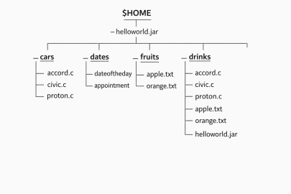
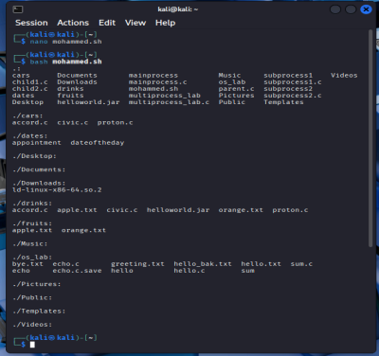

  - Write an interactive bash script that will read a type of file extension, display all those files, and count the number of files. To validate your script, display c program files, and enter “c” as the input to the bash script. [4 marks]
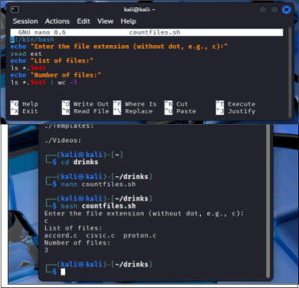

- The following Figure 1 illustrates a tree structure of some directories and files.

$HOME
subjects
faculties
books
- operating_systems
- software_engineering
- data_communication
FCS
FBE
- Linux_operating_systems
- Best_of_software_engineering

- dean
- deputy_dean
- Project_Manager
Directory

Text Files

Figure 1
  - Write a bash script (called myname2a.sh) that will produce directories and files as in Figure 1. Each text files contain its filename without the underscore character. For example: text file Project_Manager contains Project Manager). [4 marks]
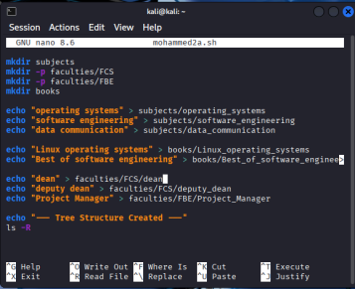

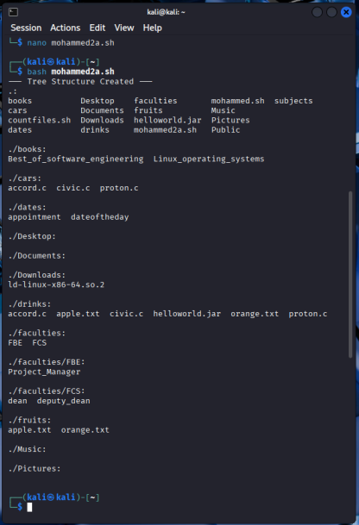
  - Complete the following table by writing the access control of directories or files that were produced. Given is the access control for directory called book. [2 marks]

Directory/File | Access Control
books | drwxrwxr-x
subjects | drwxrwxr-x
Best_of_software_engineering | -rw-rw-r--
FCS | drwxrwxr-x
project_manager | -rw-rw-r--

  - Write another bash script (called myname2c.sh) that will change the access control of the directories and files based on the following information: [4 marks]

Directory/File | Users
Directory/File | Owner |  |  | Group |  |  | Public
subjects | ❐ | ❐ | ❐ | ❐ | x | x | ❐ | x | x
Best_of_software_engineering | ❐ | x | ❐ | x | ❐ | x | x | x | x
FCS | ❐ | ❐ | x | x | x | x | ❐ | ❐ | ❐
project_manager | x | x | x | x | ❐ | ❐ | x | x | ❐

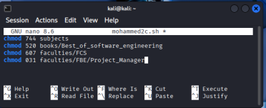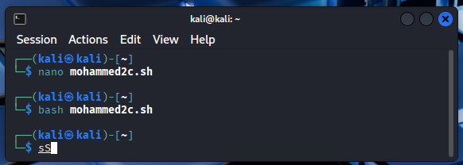

  - Complete the following table by writing the access control for each directory or file after executing the bash script in question 2(c)). [2 marks]

Directory/File | Access Control
subjects | drwxr--r--
Best_of_software_engineering | -r-x-w----
FCS | drw----rwx
project_manager | -----wx--x
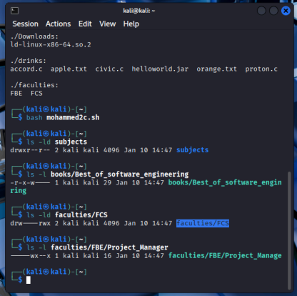

End of Lab 3

